**Disabled Poets Prize 2025 - Key Dates**

**Entries open**

* Entries can be submitted from **9am, Monday 9 September 2024**

**Workshops**

To support you in making your submission/s to the Disabled Poets Prize, we are running two FREE online and BSL interpreted workshops:

* **Wednesday 9 October, 6.30pm-8pm**

Susie Wilson, Best Unpublished Pamphlet Prize winner 2024, will run a workshop on *Putting Good Pamphlets Together.* You can book your place by visiting: [bit.ly/4e6X9Pj](https://bit.ly/4e6X9Pj)

* **Thursday 10 October, 6.30pm-8pm**

Gayathiri Kamalakanthan Best Single Poem Prize winner 2024, will run a workshop on editing your poems. Book your place by visiting: [bit.ly/4dMlaLF](https://bit.ly/4dMlaLF)

**Closing date**

* The closing date for entries is **1pm on Monday 4 November 2024**

**Announcements**

* Entrants across all the Prize categories will hear the outcome of their submission and if it has made the longlist or shortlist by **the end of January 2025**
* Shortlisted poets and the name of their work will be announced in **the first week of February 2025**
* The public announcement of the winners of the Prize will take place online on **Saturday 29 March 2025**

**Thanks**

The Disabled Poets Prize is a collaboration between CRIPtic Arts, Spread the Word and Verve Poetry Press. The 2025 Prize is supported by the Authors Licensing and 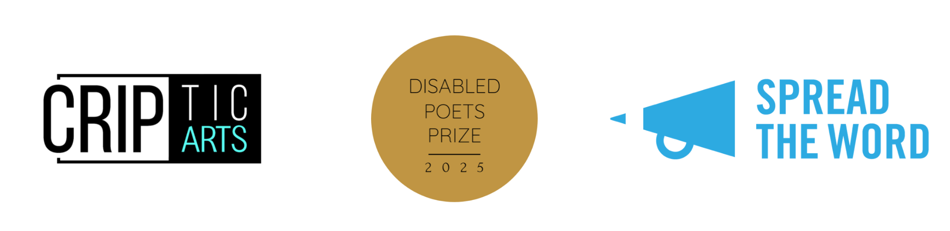Collecting Society (ALCS).